**Health Finder: Classification System and Recommender System for Hospital to Users**

**Summary:**

Any time one has to know about the near by hospitals in a certain location. So in the deluge of options provided by the social networking websites it often leads to a situation of choosing the right option. So our application provides a list of recommended hospitals based on the location. Here we will be able to track the user history and store them in a file to recommend his/her well opted hospitals near to user.

**Design:**

In order to suggest the hospitals we have included the concepts of classification and recommendation. Here classification will be done on the basis of location and recommendation will be done.

**Integration Model and Algorithm:**

The integration model primarily consists of two part. They are:

* The classification of the hospital data should be done on basis of location and hospital name should be pushed to the Solr
* The user data will run through a recommendation algorithm and the result of these algorithm should be integrated with user id specified by the user and should be recommended as items for his search specification.

**Implementation:**

**Classification/ Clustering algorithms:**

**Classification Algorithm:**

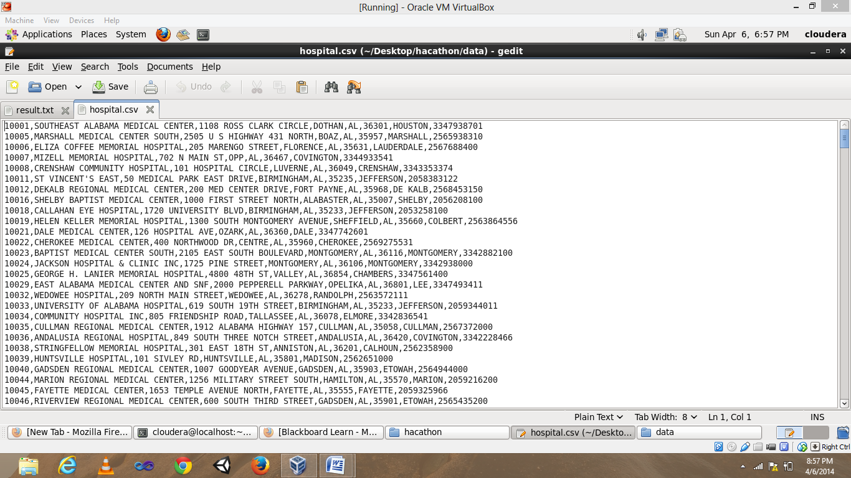

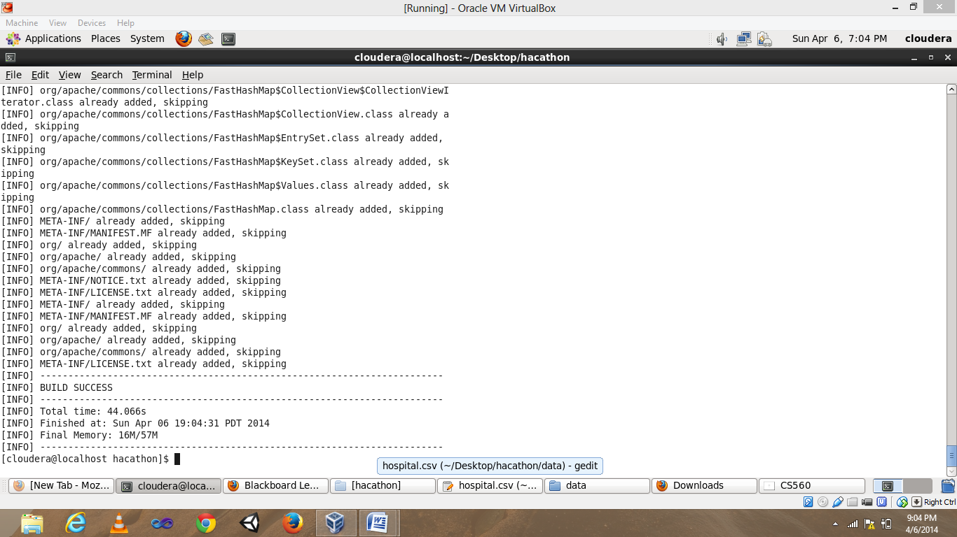

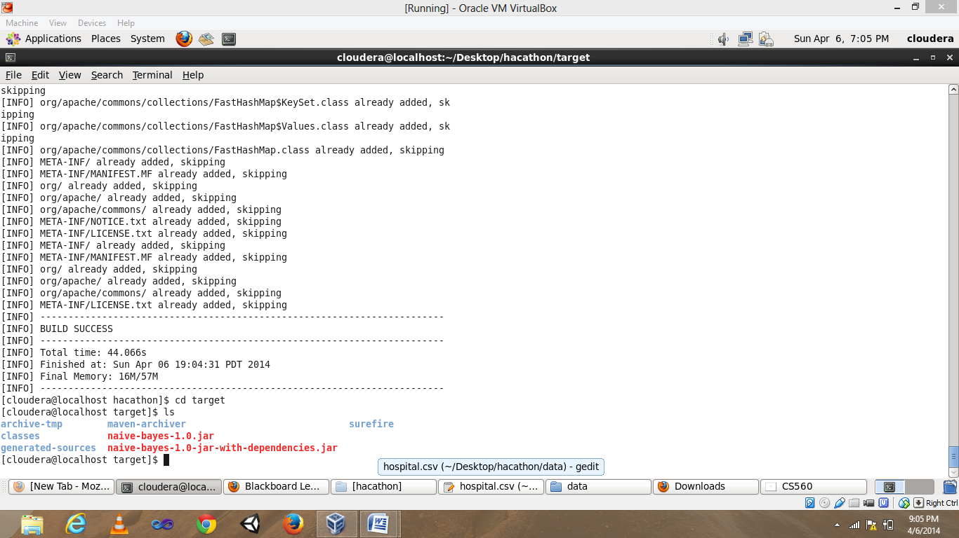

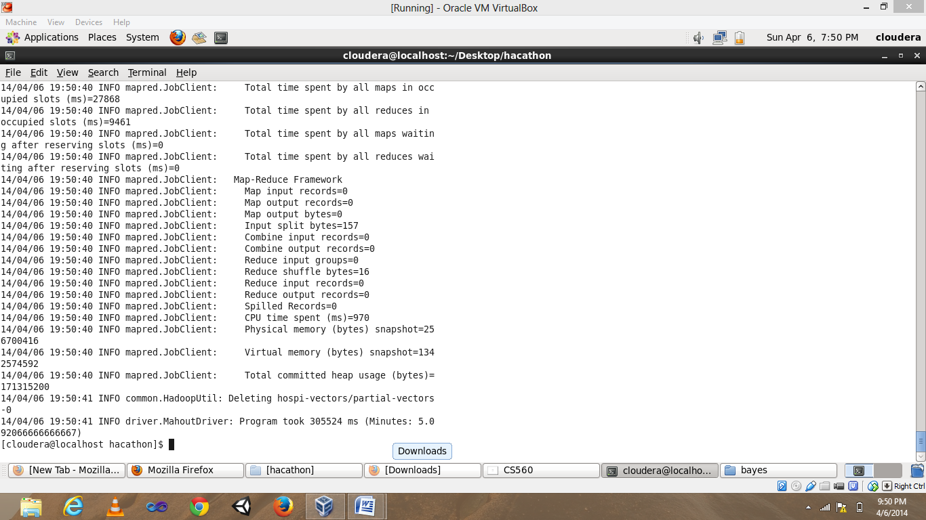

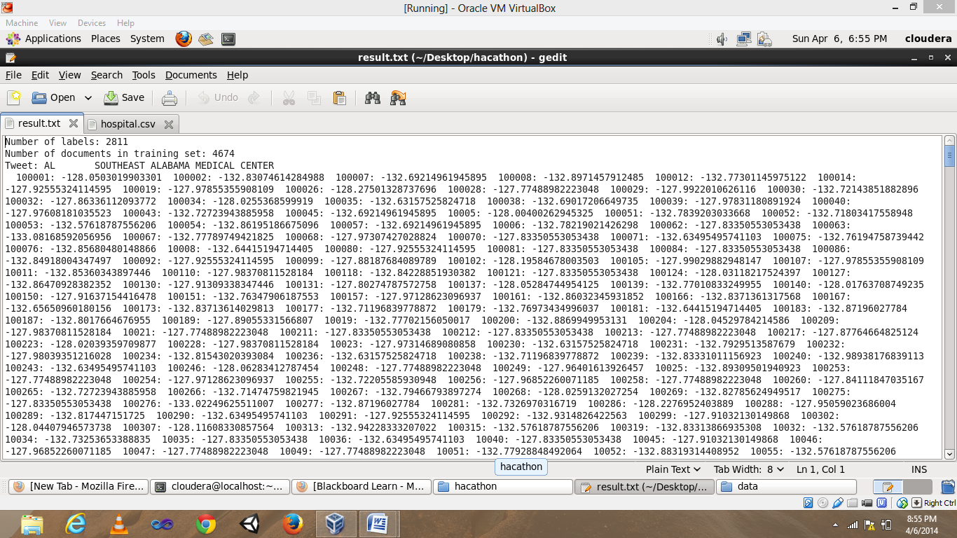

**Recommendation Algorithm:**

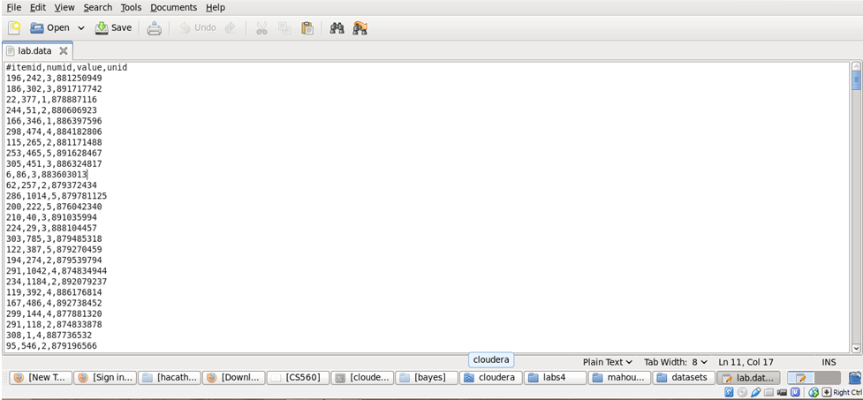

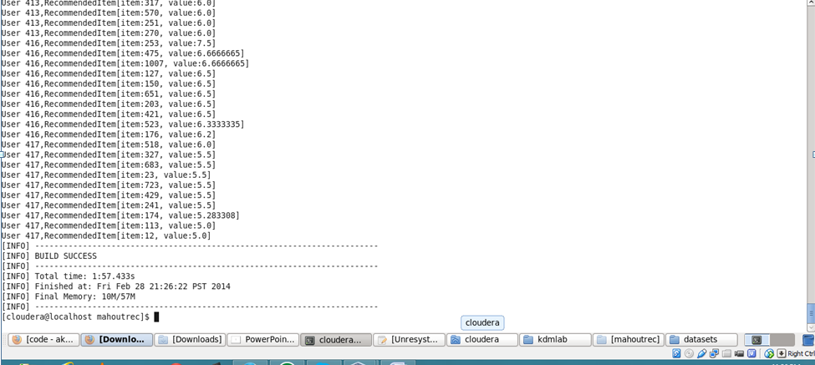

**Solr Indexing:**

Solr indexing for the movies clustering was primarily based on the id and the title. The id consists of the hospital name and title consists of location of hospitals .

Pushing into solr :

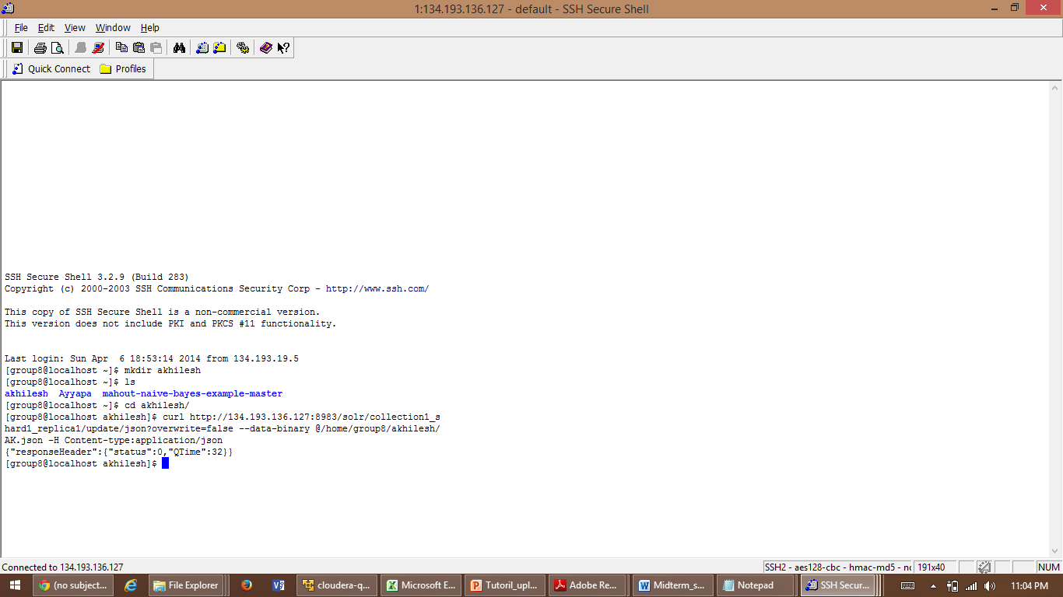

retrieving data from solr :

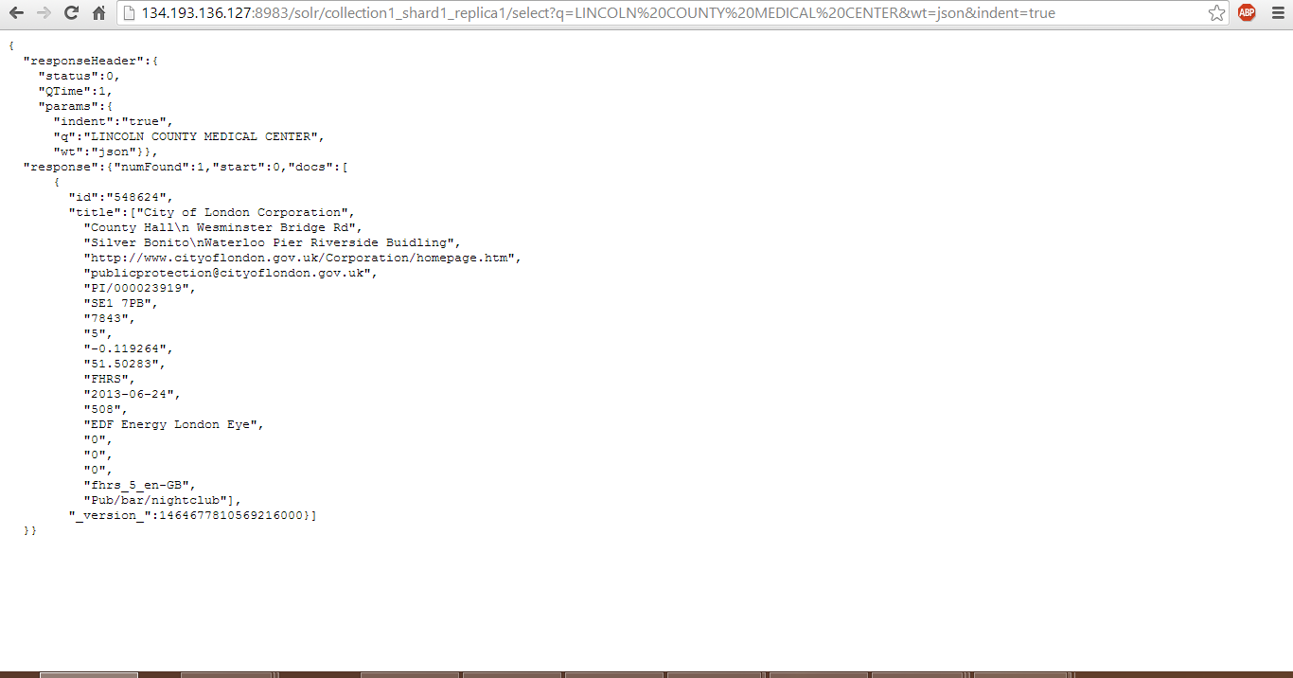

**Application Interface:**

The GUI is being developed in HTML5 and the internal operations such as retrieval of data from Solr and storing of user specifications are done through the java script. However we were unable to prepare the user credentials, for each user and track their history.

